CADANGAN PENGURUSAN PERUBAHAN

Petender hendaklah mengemukakan pelan program pengurusan perubahan (change management) meliputi pendekatan program, proses yang terlibat, kaedah pelaksanaan dan kriteria bagi mengukur kejayaan perlaksanaan serta melibatkan Pasukan Projek BERNAMA secara langsung dalam kerja-kerja berkaitan.

Petender hendaklah memastikan program pengurusan perubahan (change management) yang dikemukakan adalah efektif dan hasilnya semua pegawai BERNAMA yang berkepentingan dalam menggunakan aplikasi Bernama Mobile Dengan AI Personalisation yang dibangunkan ini mempunyai kemahiran, khasnya berkaitan penyelenggaraan, pentadbiran dan pengurusan, pembangunan kandungan, penggunaan dan latihan.

Petender hendaklah memastikan pengetahuan dan kemahiran penggunaan aplikasi Bernama Mobile diberikan, khasnya kepada petugas-petugas BERNAMA.

Contoh pelan-pelan bagi pengurusan perubahan adalah seperti berikut :

- Pelan Komunikasi (dalaman) (bulletin, launching, kick off, email blast, notice board, brochure, bunting, montaj, banner, video clips)— perincikan bilangan.
- Pelan Latihan Pengguna bagi semua peringkat warga organisasi yang terlibat secara langsung
- Pelan Promosi (luaran) (roadshow, media massa, pameran)- perincikan kekerapan
- Pelan-pelan lain yang berkaitan

Change Management

The change management process involves changes of work process throughout the organization or to some part of the organisation. The changes can sometimes be easy to adopt but the adoption can be slow. The process of how to control the flow of information to the employees is the key to delivering the message in the right way.
The software systems can be the key agent in delivering such organization changes. During the development phase of Bernama Mobile, our team would anticipate such changes and we would prepare with our preliminary ways to support BERNAMA in rolling out these changes.
While the organizational changes are taking their effect, the development process can take a serious hit in control management, review process, feedback and decision making from the BERNAMA side. For making sure the development process stays close to the project execution plan, our team will always be prepared to communicate the project details to the changing management structures and reporting authorities. This may also involve helping BERNAMA circulating brochures and banners on the underlying changes happening. Our core process involves the following steps:

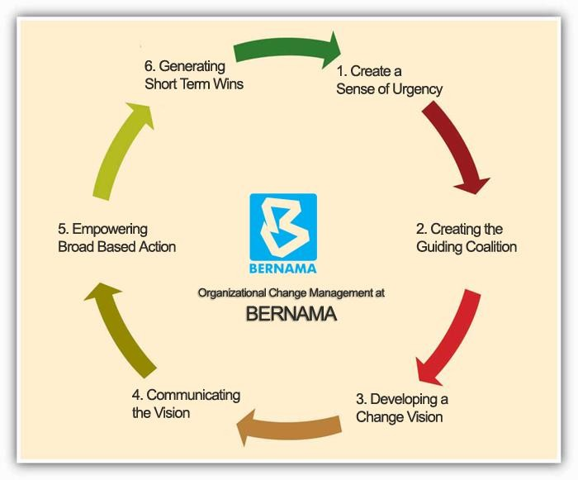

Create a Sense of Urgency

It’s very important when such organizational changes are happening, it requires the employees to understand the urgency to adopt the change. The reporting methods and process can be get diluted in no time and in most cases the senior resources in the organization need to take up the responsibility and step up. We believe that working closely with BERNAMA management we will be able to help them expedite the sense of urgency message through the board. The key to deliver the message right is to stay closest the roots of the values of the employees, create messages that are simple and imaginative, and call people to aspire.

Creating the Guiding Coalition

To bring in an organization change, it requires a team to deliver the message right. The team needs to work on the vision, communicate it to vast number of people, eliminating all the key obstacles, generating short term wins, leading and managing dozens of change projects and anchoring new approaches which are deep to the organization culture.
We will help BERNAMA develop that coalition inside the company and help them broadcast the message in an effective way.

Developing a Change Vision

The change in vision can be misleading for a lot of employee who don’t receive the message properly. The vision has to be simple and possess the following attributes:
- Imaginable
- Desirable
- Feasible
- Focused
- Flexible
- Communicable

Communicating the Vision

During the development of Bernama Mobile Apps, our team will help with delivering the message of the transformation of the vision. The key elements we would focus on are:
Simple – No Techno bubble or jargon

Vivid – A verbal picture is worth a thousand words

Repeatable – Ideas should be able to be spread using any one and anywhere.

Invitational – Two way communication is always more powerful than one way communication

Empowering Broad Based Action

Management Information systems can have a big impact on the successful implementation of the change of vision. Up to date competitive information and market analysis and the ability to communicate effectively throughout the company in a cost effective way can speed up feedback loops and provide information to the employees in an effectively manner.

Generating Short Term Wins

One of the key aspects in the organization are to show that the new change in vision works and would allow employees to perform better. While our team would be working with BERNAMA, sending out the message that the organization is performing up to the par and with the implementation of the latest software, their ability to deliver and enhance export services would increase the company growth and much more. This would help win short term and build confidence in the employees to deliver under pressure and plan smartly.

Planning Change Management

Communication Plan (Internal)
We propose a comprehensive communication plan to be executed at Bernama in order to ensure that all stakeholders are kept up- to-date on the objectives, progress, and adotation of this implementation project. In this regard, a communication plan document will be prepared. The plan will outline communications activities by timeframe, audience, key messages, recommended medium (e.g. email, posts on Bernama notice boards), and stakeholder responsibilities.
Some important questions that our communication plan will aim to address are as follows:

1.1. Why is this change happening and what is the risk of not changing?

When individuals learn of a change, their first question is "why is this happening" - whether personal or professional change. Senior leaders tend to focus on the 'vision' of the future state, and project teams tend to focus on sharing their great new idea. Our first communications will be focused on why the change is happening. And it will continue and reinforce the 'why' throughout the entire project, especially if time elapses between your first communication and the start of implementation.

1.2. What's in it for me (WIIFM)?

Making a change is a personal choice, no matter what senior leaders believe. Communication about change must resonate. To be effective, communications must get at what I, as an employee, care about and value. To gain my support, we will provide a compelling case for how I will be better off or what I get out of engaging in the change. Answer WIIFM - "what's in it for me?" - early and often in our communications.

1.3. Who will be originating the communication?

Employees prefer to hear messages from people in the organization. One of the biggest and most common mistakes others can make is to have a project team sending all of the communications. We will ensure stakeholders within Bernama are part of all communication.

1.4. What would be the medium of communication?

Face-to-face communication was identified at the most effective form of communication. While it is more time intensive, we do not underestimate the value that face-to-face communication creates. Emails and notice boards are others.

1.5. What will be the frequency of key messages?

It is important to repeat key messages a number of times. The first time we announce a change to employees, they are often wondering how it will impact them and not focusing on the details of what you are communicating about. Repeating key messages is important to ensure that what want to get across is being heard by employees.

1.6. Will there be two-way communication?

We need to craft and plan for two-way communications. Give employees the opportunity to share their concerns, provide their feedback and ask questions. Two-way communications create buy-in and provide answers in real-time.

User Training Plan
A comprehensive user training program will be essential for the successful implementation and adoption of the development of Bernama Mobile Apps. This will included focused workshops for various roles (e.g. editors, sub editors, desk deditors, and even administrators and IT users). Some of the artifacts which we will produce for Bernama users as part of training are as follows:
  - User guides
  - Pamphlets
  - "How to" check lists
  - Guided Hands-on training workshops
  - How to perform the old tasks better with the new systems

